Seldin: The Ssec rankings were then filtered ensuring that genes were

primarily expressed by the origin tissue. This was accomplished

by manual inspection of each gene in multi-tissue expression

panels available via BioGPS (Su et al., 2002; Wu et al., 2009) in

both mouse and humans (representative examples using

BioGPS arrays shown in Figure S3). Genes not detected in

BioGPS arrays were investigated for tissue specificity using the

UniProt literature query for ‘‘tissue specificity.’’

This was done after calculation of Ssec matrices. Manual inspection of top genes

For this particular test, it does not appear that they focused on tissue-specific genes at all. Solely focused on the categories secreted and nonsecreted.They tested this with QQPlots

What are BioGPS Arrays?

Would it be useful at all to look at individuals instead of strain means?

## CHECK INF!!!

Do I want to try full dataset as target?

Using BioGPS to find Tissue-Specificity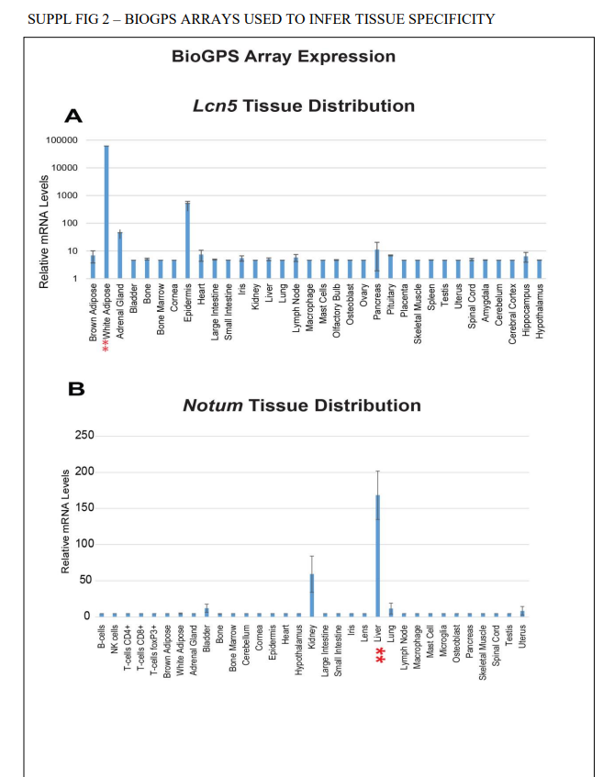

Used to compare Secreted and Non-Secreted